AntennaPod-4776

ID-271

Apk

2.1.1

Bug report description

<https://github.com/AntennaPod/AntennaPod/issues/4776>

**Steps to reproduce**:

1. Go to the "Playback History"
2. Press on one unplayed (played) eposide and mark it as played (unplayed).

**Expected behaviour**:

The unplayed eposide should turn grey immediately after you mark it as played.  
The played eposide should turn to the original color immediately after you mark it as unplayed.

**Current behaviour**:

The status (color) of the eposide does not change until you reenter the "Playback History"

**First occurred**: (e.g. about x days/weeks ago)

today

**Environment**:

Nothing special

Screen shots sequence

Listen to any of the eposides, then it will show up in the playback history, then go to playback history

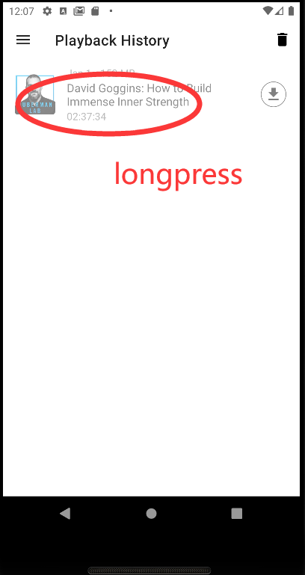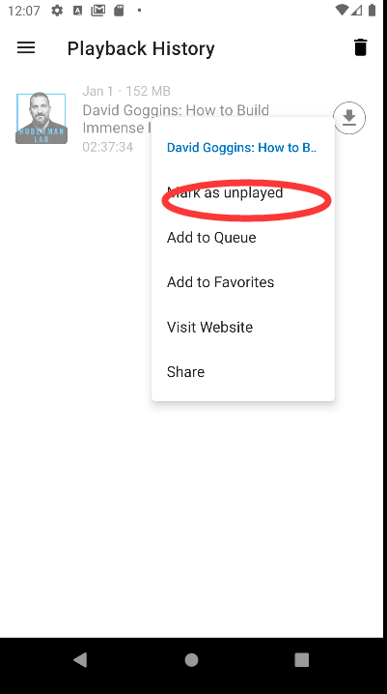

As you can see, the episode remains gray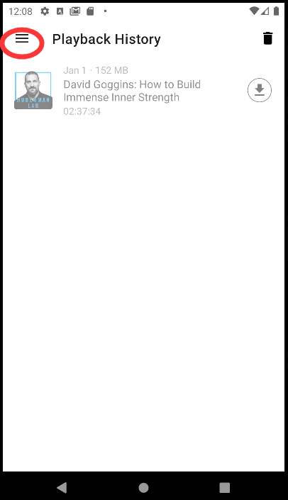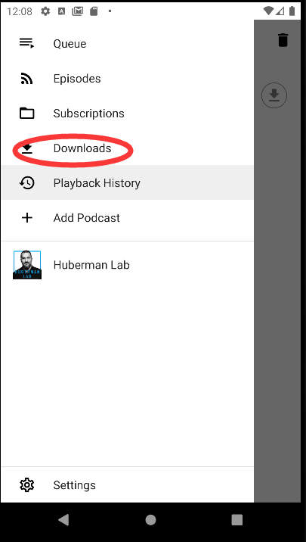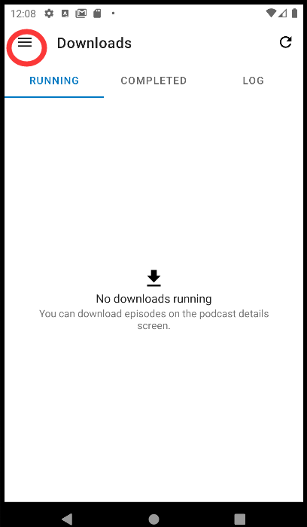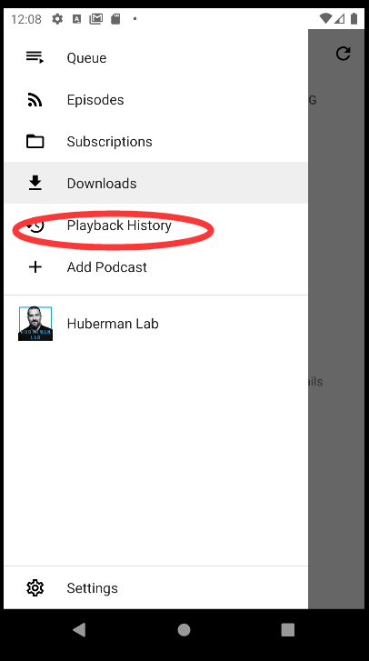Now it turns out black(after you go to another page and come back)